ORAU uses an email encryption service through Zix Corporation, a technology solutions provider with experience providing secure email applications to healthcare, finance and government institutions. The additional layer of security for email messages is part of our responsibility and ongoing effort to secure your sensitive personal or business information.

**How it works**

1. An email message from ORAU will be encrypted if it contains Personally Identifiable Information (PII) or if the email asks you to return information or forms that contain PII. Encrypted messages will be sent to the **ORAU/ORISE Secure Message Portal.** You can be confident the notification is legitimate and you can safely follow the instructions to access the ORAU/ORISE Secure Message Portal to read and respond to emails.
2. If you receive an encrypted message, the body of the email will look like this:

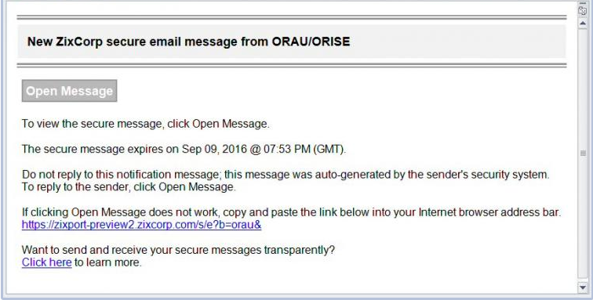

1. When you receive this message, you will be prompted to log into the portal to view the email. You will complete a one-time registration process before accessing the portal for the first time.

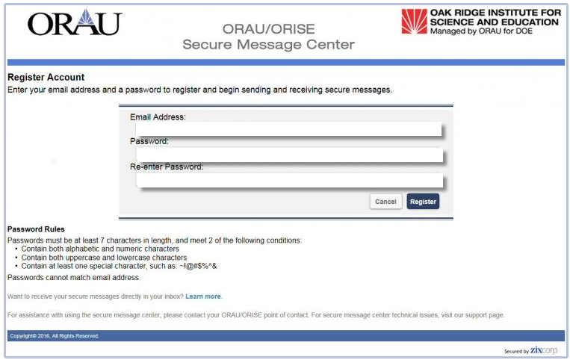

1. To complete your registration, you will receive the following email from [orau.notification@zixmessagecenter.com](mailto:orau.notification@zixmessagecenter.com):

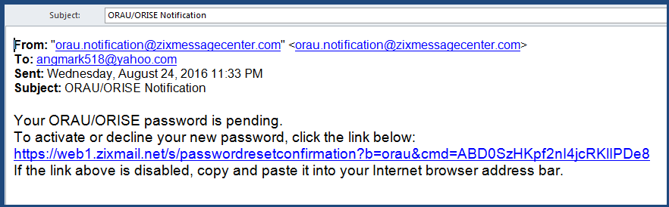

1. After you register and sign in, you can view the email message and reply. When you reply, your email and any files that you attach will automatically be encrypted.

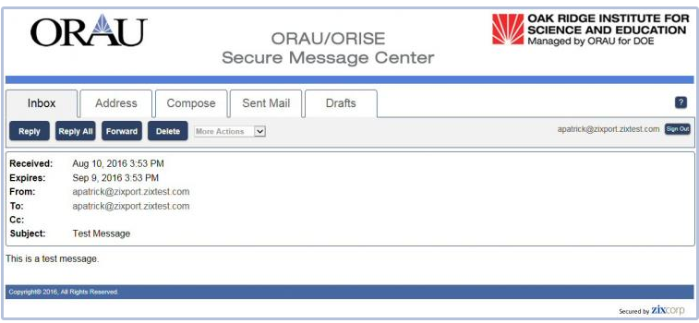

** To Initiate a secure email to ORAU\ORISE **

We also have a *direct link* to the ORAU Secure Message Center: <https://web1.zixmail.net/s/e?b=orau&>. This link will take you directly to the **ORAU/ORISE Secure Message Portal** where you can compose a secure message to anyone at ORAU. Your email and any files attached to your email will automatically be encrypted.

More information about sending and receiving encrypted messages and the ORAU/ORISE Secure Message Center is located at <https://www.uapguide.com/oak-ridge-associated-universities/customer/introduction>.

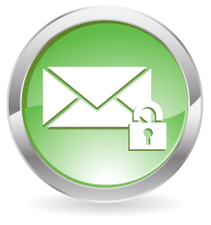**Zix Frequently Asked Questions (FAQs)**

**Who must complete the one-time registration to access the ORAU/ORISE Secure Message Center?**

Answer: All external recipients who do not subscribe to ZixCorp encryption service. If an external recipient subscribes to ZixCorp encryption service then the ORAU encrypted emails go directly to external recipients email box.

**How does an external user complete the one-time registration to access the Secure Message Center?**

Answer: The first time the external user receives a secure email, they are asked to register at the Secure Message Center. The user must then register with the same email address that received the notification to begin accessing your secure messages. Are instructions available to the external user if they should need to change their email address?

**Can ORAU reset external user passwords to the ORAU/ORISE Secure Message Center?**

Answer: No, the ORAU/ORISE Secure Message Center provides the external user the capability to reset their own password.

**How does an external user reset their password?**

Answer: Go to the Secure Message Center, from the **Sign In** screen, click **Forgot your password** and select **Reset** and follow the instructions.

**Do passwords need to be activated?**

Answer: If the password is changed at any time then it must be activated. To activate the password:

Go to your email **Inbox** and find the new email message with "Secure Email Notification" in the **Subject**.

Open the email and click the **ACTIVATE** your new password link, then select **Continue**.

**What email address is used to send the encryption notification to the external recipient?**

Answer: Encryption notifications are sent from your ORAU email address, such as [keri.cagle@orau.org](mailto:keri.cagle@orau.org).

**Can an external user initiate an email to an ORAU employee through the Zix Center?**

Answer: Yes. After the external user receives the first encrypted email from ORAU and completes the one-time registration they can initiate encrypted messages to ORAU employees. They can bookmark the Secure Message Center log-in page and compose a message new to ORAU/ORISE employee.

**Will the Secure Message Center allow the recipient to Reply to All on the original email (non-ORAU email addresses)?**

Answer: Yes. External recipients have the option to reply to just the person who sent the message using the **Reply** button or to reply to the sender as well as any other recipients using the **Reply to All** button. Additionally address may not be added when replying to a message.

**If multiple recipients, such as mentors, participants and sponsors are included in an encrypted message, and one person hits Reply All, will all parties be required to use the Secure Message Center to access the reply message?**

Answer: Yes, all messages replied to from within the secure portal will also be encrypted and will require all recipients to log in to access the message unless they are ZIX subscribers.

**If another address needs to be included on a reply, what is the best method for the external user to make this change to the original message?**

Answer: Another email address cannot be added when replying to a message in the ORAU/ORISE Secure Message Portal. The message can be forwarded but only to an orau.org or orise.orau.gov address. In order to send the message to a non-ORAU/ORISE email, the message will need to be downloaded and saved to the external user’s computer and a new email composed outside of the ORAU/ORISE Secure Message Portal.

**Can the recipient save the encrypted emails and associated attachments?**

Answer: Yes. The email can be easily saved by using the “More Actions” drop down next to Reply, Forward, and Delete buttons to save message and/or save attachments.

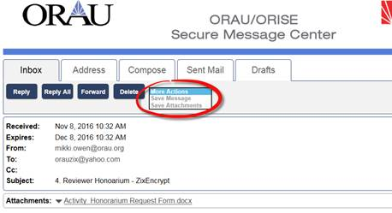

**After the recipient opens the message in the Secure Message Center will the email remain in the Secure Message Center?**

Answer: No. The messages expire after 30 days. The email can be easily saved by using the “More Actions” drop down next to Reply, Forward, and Delete buttons to save message and/or save attachments.

**When the message expires will the sender receive an email notification stating the external recipient did not retrieve the message?**

Answer: Only the sender receives notification the unread message will expire.

**Do the messages sent to ZixCorp subscribers expire if not read?**

Answer: Yes, after 30 days; however the sender will receive a notification that the message expired.

**If the external recipient currently subscribes to Zix and their email goes directly to their inbox, will the email expire after 30 days?**

Answer: No, only emails received through the ORAU/ORISE Secure Message Center expire.

**Does the recipient get a reminder email before the message expires in the ORAU/ORISE Secure Message Center?**

Answer: No, only the email sender will receive an expiration notice when the message has not been read. The notice will be received on the day the message expires; currently set 30 days from message send date.

**Can an external recipient forward a message from the Secure Message Center?**

Answer: Yes. External recipients can forward messages in their Secure Message Center**Inbox** to other ORAU/ORISE domain addresses. There is not the ability to forward other emails addresses outside of the ORAU domain.

**Does Zix offer more languages than English?**

Answer: Yes. To display the Secure Message Center in another language select your language from the **Language** drop-down box on the Sign In screen. In addition to the Secure Message Center displaying the chosen language, all notification messages and the online help automatically display in your chosen language. Cookies must be enabled on your internet browser to use the **Language** feature.